Animal Trait Ontology Brower’s User Guide

Introduction:
Animal Trait Ontology is an HTML application which allows users to browse for the details regarding traits of animals. At present the all the information in the site is only regarding pig, which could be further expanded for different species. The ATO editor helps the user visualize the data in a tree format.

The Main Window:
ATO Browser’s main page gives you the following options to do
- Browse the Ontology
- Perform Search
- Download ATO editor

Browse the Ontology
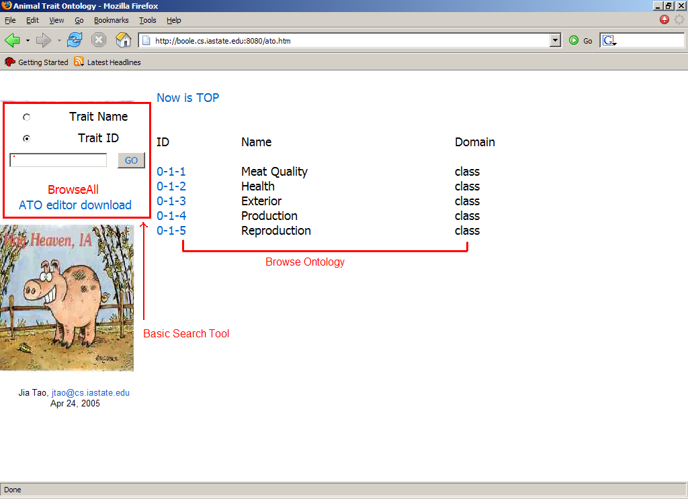
Figure 1

Ontology Tree Structure
The structure of the ontology is presented as a tree of terms. The top term or node is the highest level of the ontology. The root of the tree is ATO(Animal Trait Ontology). We assign the ATO ID 0.It has children that are species. Now we only one species that is ‘sus scrofa’, its ID is 0-1, the next species’ ID will be 0-2.

The relation between 0 and 0-1 is ‘Has_a’, so is the relation between 0-1 and 0-1-1.
So the 0-1 is like the father of 0-1-1, 0-1 can has many children. As 0-1-1 has children 0-1-1-1 and 0-1-1-2.

Understanding term line: 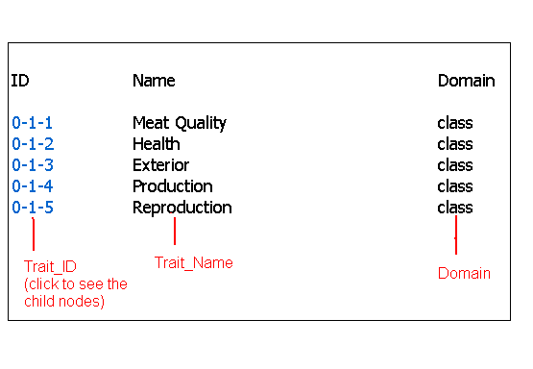
Each line in the tree contains one term and several pieces of information about the term.

Trait_ID: Click on the trait id to see the children of the particular trait.

Trait_Name: This represents the name of the trait which has the corresponding id as in Trait_ID.

Domain: It represents the level of hierarchy of the trait. It could take the values class, type and trait. If the domain of the trait id is trait and if we click Trait_ID we get to see the details regarding the trait.

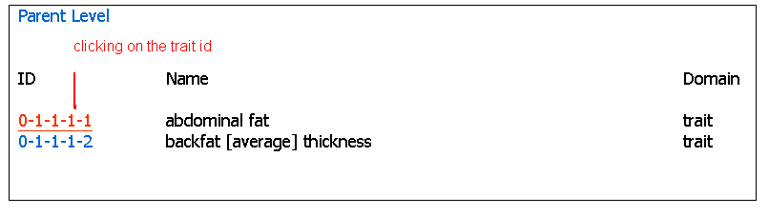
Figure 3

In the above figure clicking on the Trait_ID 0-1-1-1-1 which has the domain value trait displays the details of the trait. The details include the Trait_ID, Trait_Name, Abbreviation, Custom_name, Trait_Desc, Measurement and the scale unit. It also indicates that this particular Trait has no children.

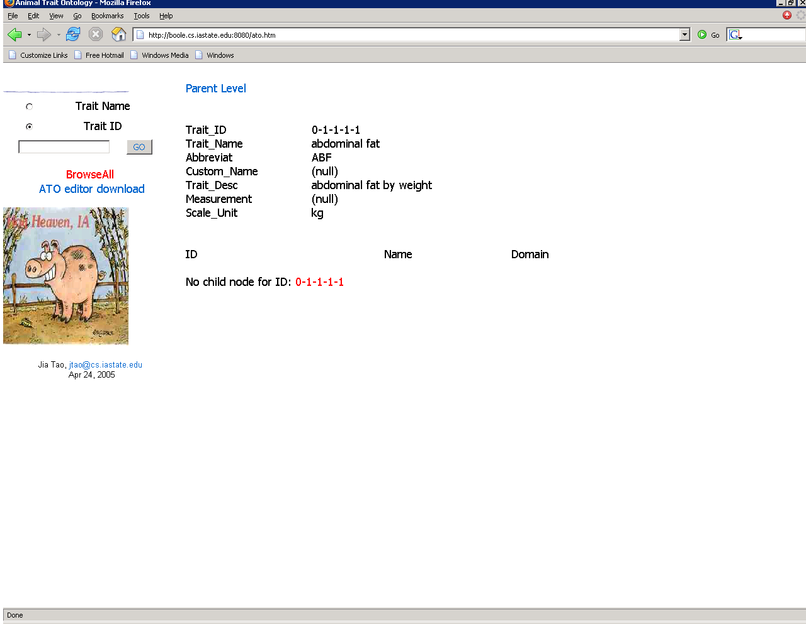
Figure 4

Perform Search:
The ATO website allows you to perform search based on the trait id or trait name.

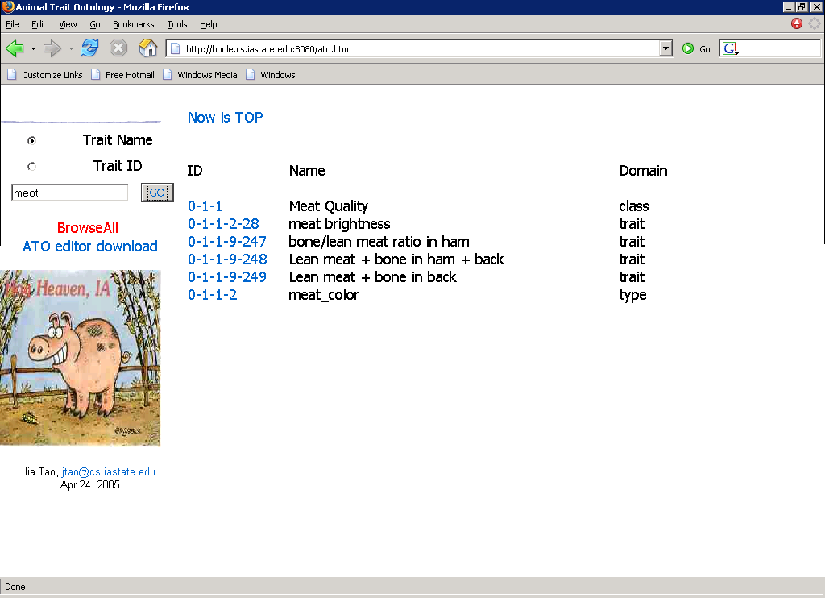
Figure 5

The above figure gives us a idea of how the search is performed. The search can be performed based on the values of the trait id or name. In the above snapshot the search is performed for the names of the traits which contain the word “meat”. When the user clicks the Go button , the database is queried for the names of the traits which contain the substring meat and the results are then displayed.

Download the ATO editor:
The ATO website allows the user to download the ATO editor. When the user clicks the hyperlink ATO editor download, a new window pops up which provides the user with the options to download the editor. The new window popped up also contains a snap shot of the ATO editor. The window that pops up looks like the one in figure 6.
